Orford Senior Center Newsletter, 2022

Please Join Us….
GCSCC will be commemorating our 50th anniversary in July!
When: Sat., July 9th
Time: 12:00pm – 2:30pm
Where: Plymouth Regional Senior Center
8 Depot Street, Plymouth, NH
*Activities for all ages, lunch available to purchase, raffles, music, and more!*
Orford Senior Center
PO Box 98, Orford, NH 03777
603-353-9107 / https://www.gcscc.org/
*Please note that the Orford Senior Center will be closed on Monday, July 4th, in honor of Independence Day!*

Bingo in July – Thursdays, from 9:00am - 10:30am!
Masks are optional; sign-in/sign-out required.
Grab and stay option – get a meal from our grab and go program; bring it inside to eat! (Through 11:30am).
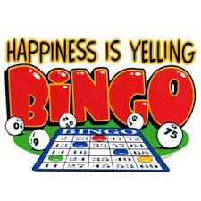
Orford’s Own 50th GCSCC Celebration
When: Thursday, July 14th
Where: At the Orford Senior Center
Time: 11:00am – 12:00pm
Order a meal (to go or stay and eat with us), and enter our raffle! Reservations are preferred.
Call 603-353-9107

